实验一 五子棋游戏
1．实验目的
（1）了解机器博弈相关技术；
（2）掌握机器博弈的分析方法。
2．实验内容
（1）实现简单的五子棋游戏；
（2）插入一个下载的棋盘图像作为自己的棋盘；
（3）插入一段音乐实现背景音乐的播放；
（4）当有输赢出现时弹出一个显示战况的对话框；
（5）在菜单栏上添加一个战况的标题，当单击时弹出显示当时战况的对话框。
3．实验报告要求
（1）简述实验原理，并请给出实现算法及程序流程图。
本实验旨在利用机器博弈技术实现一个具备人机对战功能的五子棋游戏。游戏包括三个部分：图形用户页面（GUI）、游戏逻辑设计与机器博弈人工智能设计。游戏以Python为基础设计语言，利用内置tkinter、Pillow与pygame库实现GUI。五子棋核心AI基于经典的机器博弈理论，设计“简单-困难”五种模式，其中困难模式核心为“博弈树-极大化最小值算法”，通过递归搜索预判未来棋局走向。为解决递归效率低等问题，引入“α-β剪枝”优化。下面详细介绍三个组成部分。程序总体流程图见下。
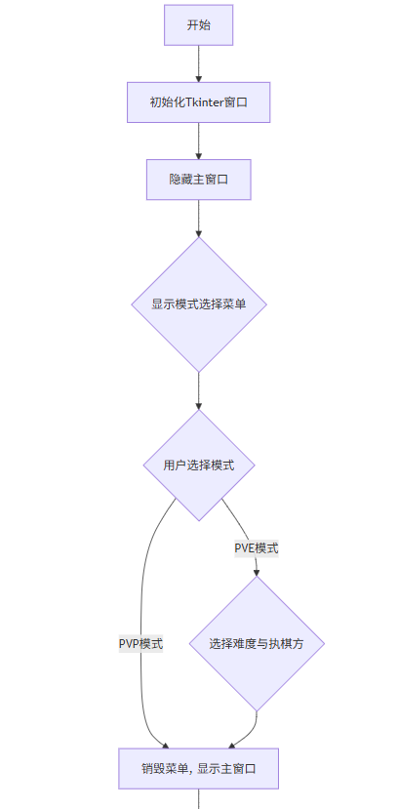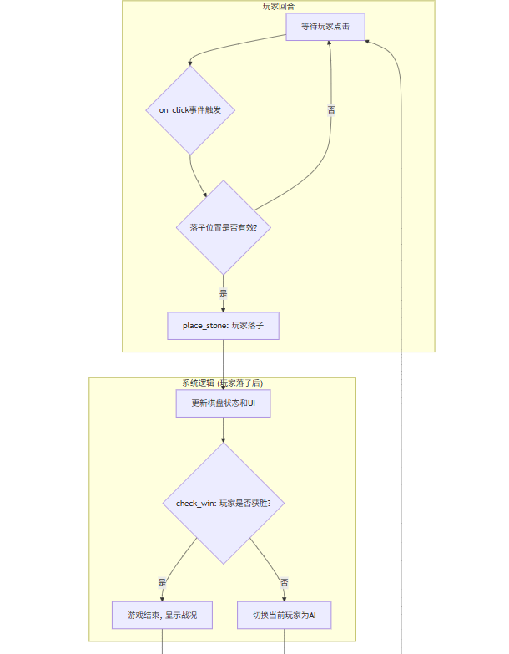
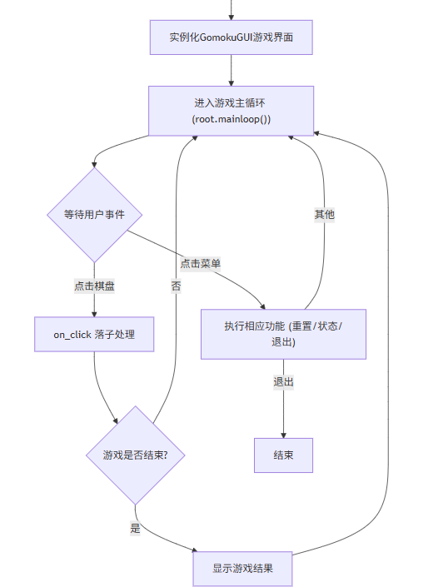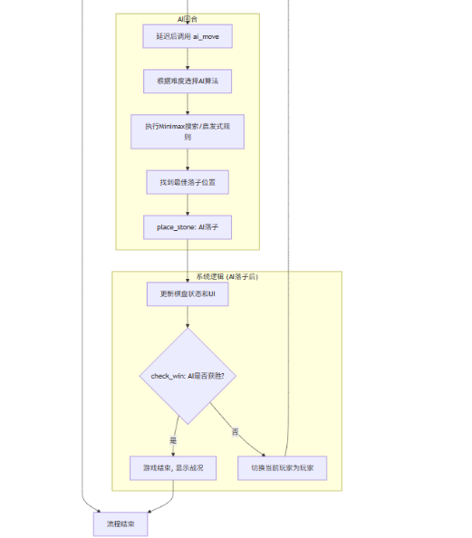
图1-1 主程序流程图、PVE流程图
1.图形用户页面（GUI）：采用上述内置库构建图形页面。利用tkinter.Canvas构架背景及UI框架，加载准备的Chess1.png、Black_Chessman.png与White_Chessman.png作为棋盘背景、黑棋与白棋。绘制状态栏与战况栏。设计消息循环，监听鼠标点击操作，出发绑定事件，响应落子行为。同时，在加载棋盘时，自动播放音乐“Chess_Bgm.mp3”。以下为部分代码展示及说明。
首页、棋盘UI设计部分：
# 初始化画布Canvas
self.canvas = tk.Canvas(root, width=CANVAS_WEIGHT, height=CANVAS_HEIGHT)
self.canvas.pack()
self.background_image = self.load_and_fit_background(BACKGROUND_IMAGE,CANVAS_WEIGHT, CANVAS_HEIGHT)
self.canvas.create_image(0, 0, anchor="nw", image=self.background_image)
……
self.status_var = tk.StringVar(value="黑棋回合")
self.status_label = tk.Label(root, textvariable=self.status_var, anchor="w")
代码1-1 首页、棋盘UI设计
以下是GUI流程图及部分GUI实例图。
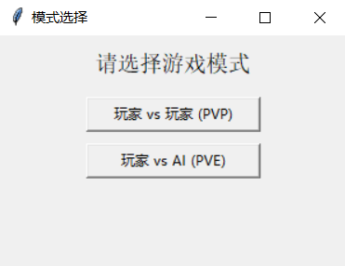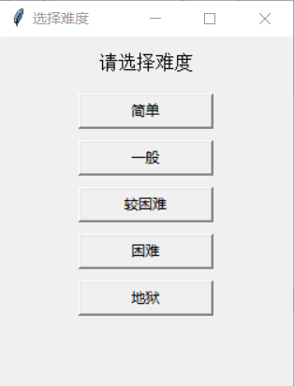
图1-2 首页、PVE页示例图
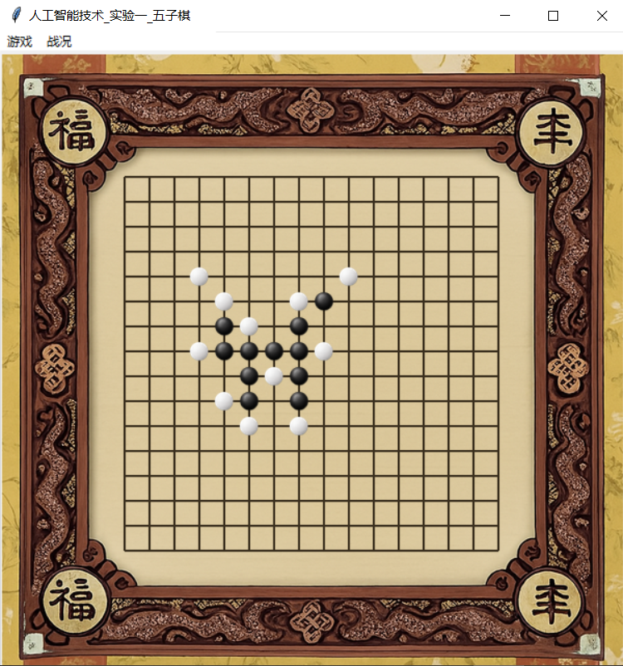
图1-3 棋盘示例图
2. 游戏逻辑设计：游戏核心逻辑，以board二维数组记录网格状态，0代表空，1代表黑棋，2代表白棋。程序设计current_player标记当前回合方。每次落子时，count_max_line计算最长连字数，超过5则判定为获胜。下面是部分核心函数的解释。
self.board = [[0]*BOARD_SIZE for _ in range(BOARD_SIZE)]
# 落子函数
if self.check_win(row, col):
winner = "黑棋" if player == 1 else "白棋"
self.winner = player # 记录胜者：1=黑，2=白
self.status_var.set(f"{winner}胜！")
self.game_over = True
messagebox.showinfo("战况", f"{winner}获胜！")
return
# 切换回合
self.current_player = 2 if player == 1 else 1
self.status_var.set("黑棋回合" if self.current_player == 1 else "白棋回合")

# AI 下
if self.game_mode == "PVE" and self.current_player == self.ai_player and not self.game_over:
self.root.after(100, self.ai_move)
代码2-1 棋盘定义、落子函数

def pixel_to_grid(self, x, y):
col = round((x - self.grid_left) / self.grid_cell_size)
row = round((y - self.grid_top) / self.grid_cell_size)
if 0 <= row < BOARD_SIZE and 0 <= col < BOARD_SIZE:
return row, col
return None, None
代码2-2 坐标转换函数
3. 机器博弈原理：本游戏设计“简单-困难-地狱”共五种难度分级。
·简单难度：ai_move1，完全纯随机落子，仅限制落子范围在已存在的棋子周边几格，以防止纯随机乱下。以下是限制函数代码展示。
def get_candidate_moves(self):
candidate_moves = set()
for row in range(BOARD_SIZE):
for col in range(BOARD_SIZE):
if self.board[row][col] != 0:
# 在已有棋子周围2格范围内寻找空位
for row_offset in range(-2, 3):
for col_offset in range(-2, 3):
neighbor_row = row + row_offset
neighbor_col = col + col_offset
if 0 <= neighbor_row < BOARD_SIZE and 0 <= neighbor_col < BOARD_SIZE and self.board[neighbor_row][neighbor_col] == 0:
candidate_moves.add((neighbor_row, neighbor_col))
# 如果棋盘完全为空，默认返回中心点
if not candidate_moves:
return [(BOARD_SIZE // 2, BOARD_SIZE // 2)]
return list(candidate_moves)
代码3-1 获取候选列表
·基于规则的启发式算法：设定阻止四连、五连等，写死限制，当检测到四连、五连等，一定会阻止，及人为固定一些规则，AI遵守，若其他情况，则自动调用随机算法。
·极大化极小值搜寻 + α-β剪枝 + 简单评估函数。
博弈树 + 极大化极小值搜寻：整体思路采用博弈树思想，从当前棋局状态出发，递归便利寻找所有可能的下法，构成一颗巨大的博弈树。极大化极小值搜索及Minimax，递归地探索博弈树，AI（己方）作为极大化层，选择能使自身评估分数最高的走法，对手玩家则被视为极小化层，选择让AI评估分数最低的走法。交替选择，令AI能够预判后续的局势，并选择对自己最有利的走法。
α-β剪枝：对博弈树进行剪枝，如果发现某条分支无论后续如何发展，其最终得分都比已找到的其他分支要差，那么这条分支就可以被去除，无需继续搜索。极大的优化了算法需要计算的局面数量。提升效率。
为了代码可读性与可维护性，将“博弈树 + 极大化极小值搜寻 + α-β剪枝”等复用部分抽取，设计函数“ai_search”。
def ai_search(self, depth, eval_func):
best_score = float("-inf")
best_move = None
empty_positions = self.get_candidate_moves()
for row, col in empty_positions:
self.board[row][col] = self.current_player
score = self.minimax_with_eval(depth - 1, False, float("-inf"), float("inf"), eval_func)
self.board[row][col] = 0
if score > best_score:
best_score = score
best_move = (row, col)
if best_move:
self.place_stone(best_move[0], best_move[1], self.current_player)
else:
self.ai_move1()
代码3-1 ai_search概述
其中，博弈决策树部分代码如下：
def minimax_with_eval(self, depth, is_maximizing, alpha, beta, eval_func):
# 如果胜利/对方失败，则直接返回大
if self.is_terminal():
if self.winner == self.current_player:
return 100000000
elif self.winner != 0:
return -100000000
else:
return 0
if depth == 0:
return eval_func()
empty_positions = self.get_candidate_moves()
# is_maximizing True我方下棋，尽量让分数最大/False对手下棋，尽量让分数最小
if is_maximizing:
max_eval = float("-inf")
for row, col in empty_positions:
self.board[row][col] = self.current_player
eval = self.minimax_with_eval(depth - 1, False, alpha, beta, eval_func)
self.board[row][col] = 0
max_eval = max(max_eval, eval)
alpha = max(alpha, eval)
if beta <= alpha:
break
return max_eval
else:
……
代码3-2 博弈决策树
简单评估函数：博弈树本身过于庞大，需要限制搜索的深度，当搜索达到预设深度时，需要一个“评估函数”来对当前的“叶子节点”局面进行打分，分数代表了该局面对于AI的有利程度。
def evaluate_board(self):
score = 0
for row in range(BOARD_SIZE):
for col in range(BOARD_SIZE):
if self.board[row][col] != 0:
player = self.board[row][col]
line = self.count_max_line(row, col, player)
if player == self.current_player:
if line >= 4:
score += 1000
elif line == 3:
score += 100
elif line == 2:
score += 10
else:
if line >= 4:
score -= 1000
elif line == 3:
score -= 100
elif line == 2:
score -= 10
return score
代码3-3 简单评估函数

·极大化极小值搜寻 + α-β剪枝 + 优化评估函数。预设多种情况，以令函数评估。活五：最高分，直接获胜、冲四：差一个子就能连成五，通常需要防守或立即形成、活四：比冲四威胁更大，因为可以直接形成五连，或形成双冲四等等。同时，考虑双重棋型对双重棋型给予更高的分数。下面是部分优化评估函数代码。
def evaluate_advanced(self):
score = 0
patterns = {
"five": 100000,
"live_four": 10000,
"sleep_four": 5000,
"live_three": 1000,
"sleep_three": 200,
"live_two": 50,
}

for row in range(BOARD_SIZE):
for col in range(BOARD_SIZE):
if self.board[row][col] != 0:
player = self.board[row][col]
val = self.evaluate_point(row, col, player, patterns)
if player == self.current_player:
score += val
else:
score -= val
return score
# 评估某个点的棋型价值
def evaluate_point(self, row, col, player, patterns):
total = 0
directions = [(0,1), (1,0), (1,1), (1,-1)]
for dr, dc in directions:
line = self.get_line(row, col, dr, dc, player)
total += self.match_pattern(line, patterns)
return total
代码3-4 优化评估函数

·多重优化的高级推演：实验性的试图采用置换表缓存、威胁空间搜索与即时攻防检测。以更深度的搜索试图换取更智能的AI。但设备不支持，现AI落子所需时间过长，因此仅实验使用。
威胁空间搜索：AI会优先扫描棋盘，找出那些能够立即形成“活四”、“冲四”、“活三”等高威胁棋型的“关键点”，并将这些点作为最高优先级的搜索目标。可以极大地提高α-β剪枝的效率。
置换表缓存：即记忆化搜索，减少重复计算。
即时攻防检测：在深度搜索开始前，检查是否存在可以一步形成“活五”的制胜点，或者对手下一步可以形成“活五”的致命点。减少一些搜索。下面是“地狱难度”，的部分代码解释。
def ai_move5(self):
player = self.current_player
opponent = 1 if player == 2 else 2
# 初始化置换表缓存
if not hasattr(self, "_transposition_table"):
self._transposition_table = {}
empty_positions = [(row, col) for row in range(BOARD_SIZE) for col in range(BOARD_SIZE) if
self.board[row][col] == 0]
# 1. 直接必胜：如果当前玩家能立即获胜，直接下子
for row, col in empty_positions:
self.board[row][col] = player
if self.check_win(row, col):
self.board[row][col] = 0
return self.place_stone(row, col, player)
self.board[row][col] = 0
……
for row, col in candidate_moves:
self.board[row][col] = player
score = self._alphabeta(depth=2, is_max=False, alpha=float("-inf"), beta=float("inf"), player=player)
self.board[row][col] = 0
if score > best_score:
best_score = score
best_move = (row, col)
# 执行最佳落子或兜底策略
if best_move:
return self.place_stone(best_move[0], best_move[1], player)
else:
return self.ai_move2()
代码3-5 优化评估函数
（2）源程序清单。要求符合一般的程序书写风格，并包括必要的注释。
import tkinter as tk
from tkinter import messagebox
from PIL import Image, ImageTk
import random
import pygame

# 环境参数，辅助画布定位、边界判断
CANVAS_WEIGHT = 600 # 画布长
CANVAS_HEIGHT = 600
BOARD_SIZE = 16 # 棋盘网格数目
GRID_LEFT_RATIO, GRID_TOP_RATIO = 0.2, 0.2 # 坐上定位点比例
GRID_RIGHT_RATIO, GRID_BOTTOM_RATIO = 0.8, 0.8
BACKGROUND_IMAGE = "images/Chess1.png" # 背景图
BLACK_IMAGE = "images/Black_Chessman.png"
WHITE_IMAGE = "images/White_Chessman.png"
BACKGROUND_MUSIC = "music/Chess_Bgm.mp3"

class GomokuGUI:
def __init__(self, root, game_mode="PVP", ai_player=None, ai_level=1):
self.root = root
self.root.title("人工智能技术_实验一_五子棋")

# 记录属性值
self.game_mode = game_mode # PVP or PVE
self.ai_player = ai_player # AI 执棋黑/白
self.ai_level = ai_level # 困难度 1——5
self.winner = 0 # 辅助战况判断是否胜利标志

# 初始化画布Canvas
self.canvas = tk.Canvas(root, width=CANVAS_WEIGHT, height=CANVAS_HEIGHT)
self.canvas.pack()

# 加载背景图
self.background_image = self.load_and_fit_background(BACKGROUND_IMAGE, CANVAS_WEIGHT, CANVAS_HEIGHT)
self.canvas.create_image(0, 0, anchor="nw", image=self.background_image)

# 绘制棋盘网格，计算棋盘的上下边界，给背景图四周美化留空间
self.grid_left = int(CANVAS_WEIGHT * GRID_LEFT_RATIO)
self.grid_top = int(CANVAS_HEIGHT * GRID_TOP_RATIO)
self.grid_right = int(CANVAS_WEIGHT * GRID_RIGHT_RATIO)
self.grid_bottom = int(CANVAS_HEIGHT * GRID_BOTTOM_RATIO)
self.grid_cell_size = (self.grid_right - self.grid_left) / (BOARD_SIZE - 1) # 单个网格大小
# 加载棋子图片
stone_size = int(self.grid_cell_size * 1.2)
self.black_image = ImageTk.PhotoImage(Image.open(BLACK_IMAGE).resize((stone_size, stone_size), Image.Resampling.LANCZOS))
self.white_image = ImageTk.PhotoImage(Image.open(WHITE_IMAGE).resize((stone_size, stone_size), Image.Resampling.LANCZOS))
self.draw_grid()

# 绘制状态栏（部分战况）
self.status_var = tk.StringVar(value="黑棋回合")
self.status_label = tk.Label(root, textvariable=self.status_var, anchor="w")
self.status_label.pack(fill="x")

# 绘制菜单栏
menubar = tk.Menu(root)
game_menu = tk.Menu(menubar, tearoff=0)
game_menu.add_command(label="重新开始", command=self.reset_game)
game_menu.add_separator()
game_menu.add_command(label="退出游戏", command=root.quit)
menubar.add_cascade(label="游戏", menu=game_menu)
root.config(menu=menubar)

# 棋局状态 + 具体战况
self.board = [[0]*BOARD_SIZE for _ in range(BOARD_SIZE)]
self.current_player = 1
self.game_over = False
self.stone_refs = [] # 保存棋子图片的引用，以防被垃圾回收
# 新增战况菜单
status_menu = tk.Menu(menubar, tearoff=0)
status_menu.add_command(label="查看战况", command=self.show_status)
menubar.add_cascade(label="战况", menu=status_menu)

# 鼠标点击事件绑定
self.canvas.bind("<Button-1>", self.on_click)

# 设定AI执黑棋时先手下一个子
if self.game_mode == "PVE" and self.ai_player == 1:
self.ai_move()

# 背景音乐
pygame.mixer.init()
pygame.mixer.music.load(BACKGROUND_MUSIC)
pygame.mixer.music.play(-1) # 循环播放BGM

# 战况统计：计算黑/白棋数目，定义显示框
def show_status(self):
# self.board存储棋盘状态
black_chess_count = sum(row.count(1) for row in self.board)
white_chess_count = sum(row.count(2) for row in self.board)

if self.game_over:
#self.winner记录胜者
winner_text = "黑棋" if self.winner == 1 else "白棋"
msg = f"当前战况：\n{winner_text}获胜！"
else:
turn_text = "黑棋" if self.current_player == 1 else "白棋"
msg = (
f"当前战况：\n"
f"黑棋：{black_chess_count} 子\n"
f"白棋：{white_chess_count} 子\n"
f"轮到：{turn_text}"
)
messagebox.showinfo("战况", msg)

# 拉伸图片以适合画布
def load_and_fit_background(self, path, target_weight, target_height):
img = Image.open(path)
img_resized = img.resize((target_weight, target_height), Image.Resampling.LANCZOS)
return ImageTk.PhotoImage(img_resized)

# 绘制网格
def draw_grid(self):
line_color = "#3A2F1E"
for i in range(BOARD_SIZE):
y = self.grid_top + i * self.grid_cell_size
# 画横线
self.canvas.create_line(self.grid_left, y, self.grid_right, y, fill=line_color, width=2)
x = self.grid_left + i * self.grid_cell_size
# 画竖线
self.canvas.create_line(x, self.grid_top, x, self.grid_bottom, fill=line_color, width=2)

# 鼠标点击事件
def on_click(self, event):
if self.game_over:
return
if self.game_mode == "PVE" and self.current_player == self.ai_player:
return # AI的回合，阻止玩家操作

# 通过定位计算网格中的行列
row, col = self.pixel_to_grid(event.x, event.y)
if row is None or col is None:
return
if self.board[row][col] != 0:
return

# 玩家落子
self.place_stone(row, col, self.current_player)

# AI下棋算法
def ai_move(self):
if self.ai_level == 1:
self.ai_move1() # 随机下法，决策完全随机
elif self.ai_level == 2:
self.ai_move2() # 基于规则的启发式算法，设定阻止四连、五连等
elif self.ai_level == 3:
self.ai_move3() # 极大化极小值搜尋 + αβ剪枝 + 简单评估函数
elif self.ai_level == 4:
self.ai_move4() # 极大化极小值搜尋 + αβ剪枝 + 复杂
elif self.ai_level == 5:
self.ai_move5() # 多重優化的高級搜尋演算法

def ai_move1(self):
# 纯随机落子，做少许优化：仅在已有棋子周围选择。
candidate_positions = self.get_candidate_moves()
if not candidate_positions:
return # 下满了
row, col = random.choice(candidate_positions)
self.place_stone(row, col, self.current_player)

def ai_move2(self):
# 一般难度，死板的匹配规则：优先进攻（造四连/赢棋），其次选择防守，最后随机
ai_player = self.current_player
opponent_player = 1 if ai_player == 2 else 2

# 仅在已有棋子周围选择。
candidate_positions = self.get_candidate_moves()

for row, col in candidate_positions:
self.board[row][col] = ai_player
# 1. AI 自己能赢（五连子）
if self.check_win(row, col):
self.board[row][col] = 0
self.place_stone(row, col, ai_player)
return
# 2. 防守：堵对方五连
if self.check_win(row, col):
self.board[row][col] = 0
self.place_stone(row, col, ai_player)
return
# 3. AI 能造四连
if self.count_max_line(row, col, ai_player) >= 4:
self.board[row][col] = 0
self.place_stone(row, col, ai_player)
return
# 4. 防守：堵对方四连
self.board[row][col] = 0
if self.count_max_line(row, col, opponent_player) >= 4:
self.board[row][col] = 0
self.place_stone(row, col, ai_player)
return

# 随机下
self.ai_move1()

# 辅助计算最长连子数
def count_max_line(self, row, col, player_value):
max_connected_count = 1
directions = [(0, 1), (1, 0), (1, 1), (1, -1)]

for row_step, col_step in directions:
connected_count = 1
next_row, next_col = row + row_step, col + col_step
while 0 <= next_row < BOARD_SIZE and 0 <= next_col < BOARD_SIZE and self.board[next_row][next_col] == player_value:
connected_count += 1
next_row += row_step
next_col += col_step

prev_row, prev_col = row - row_step, col - col_step
while 0 <= prev_row < BOARD_SIZE and 0 <= prev_col < BOARD_SIZE and self.board[prev_row][prev_col] == player_value:
connected_count += 1
prev_row -= row_step
prev_col -= col_step
max_connected_count = max(max_connected_count, connected_count)
return max_connected_count

def ai_move3(self):
# 极大化极小值搜尋 + αβ剪枝 + 简单评估函数
self.ai_search(depth=2, eval_func=self.evaluate_board)

# 获取候选点，只在已有棋子的周围下
def get_candidate_moves(self):
candidate_moves = set()

for row in range(BOARD_SIZE):
for col in range(BOARD_SIZE):
if self.board[row][col] != 0:
# 在已有棋子周围2格范围内寻找空位
for row_offset in range(-2, 3):
for col_offset in range(-2, 3):
neighbor_row = row + row_offset
neighbor_col = col + col_offset
if 0 <= neighbor_row < BOARD_SIZE and 0 <= neighbor_col < BOARD_SIZE and self.board[neighbor_row][neighbor_col] == 0:
candidate_moves.add((neighbor_row, neighbor_col))
# 如果棋盘完全为空，默认返回中心点
if not candidate_moves:
return [(BOARD_SIZE // 2, BOARD_SIZE // 2)]
return list(candidate_moves)

# 判断游戏终局
def is_terminal(self):
for r in range(BOARD_SIZE):
for c in range(BOARD_SIZE):
if self.board[r][c] != 0 and self.check_win(r, c):
self.winner = self.board[r][c]
return True
self.winner = 0
return False

# 简单评估函数
def evaluate_board(self):
score = 0
for row in range(BOARD_SIZE):
for col in range(BOARD_SIZE):
if self.board[row][col] != 0:
player = self.board[row][col]
line = self.count_max_line(row, col, player)
if player == self.current_player:
if line >= 4:
score += 1000
elif line == 3:
score += 100
elif line == 2:
score += 10
else:
if line >= 4:
score -= 1000
elif line == 3:
score -= 100
elif line == 2:
score -= 10
return score

# 困难难度：极大极小搜索 + αβ剪枝 + 优化评估函数
def ai_move4(self):
self.ai_search(depth=2, eval_func=self.evaluate_advanced)

def ai_search(self, depth, eval_func):
best_score = float("-inf")
best_move = None
empty_positions = self.get_candidate_moves()

for row, col in empty_positions:
self.board[row][col] = self.current_player
score = self.minimax_with_eval(depth - 1, False, float("-inf"), float("inf"), eval_func)
self.board[row][col] = 0
if score > best_score:
best_score = score
best_move = (row, col)

if best_move:
self.place_stone(best_move[0], best_move[1], self.current_player)
else:
self.ai_move1()

# 博弈决策树
def minimax_with_eval(self, depth, is_maximizing, alpha, beta, eval_func):
# 如果胜利/对方失败，则直接返回大
if self.is_terminal():
if self.winner == self.current_player:
return 100000000
elif self.winner != 0:
return -100000000
else:
return 0
if depth == 0:
return eval_func()
empty_positions = self.get_candidate_moves()

# is_maximizing True我方下棋，尽量让分数最大/False对手下棋，尽量让分数最小
if is_maximizing:
max_eval = float("-inf")
for row, col in empty_positions:
self.board[row][col] = self.current_player
eval = self.minimax_with_eval(depth - 1, False, alpha, beta, eval_func) # ✅ 加上 eval_func
self.board[row][col] = 0
max_eval = max(max_eval, eval)
alpha = max(alpha, eval)
if beta <= alpha:
break
return max_eval
else:
min_eval = float("inf")
opponent = 1 if self.current_player == 2 else 2
for row, col in empty_positions:
self.board[row][col] = opponent
eval = self.minimax_with_eval(depth - 1, True, alpha, beta, eval_func) # ✅ 加上 eval_func
self.board[row][col] = 0
min_eval = min(min_eval, eval)
beta = min(beta, eval)
if beta <= alpha:
break
return min_eval

# 优化评估函数：区分活三、眠三、活四等棋型
def evaluate_advanced(self):
score = 0
patterns = {
"five": 100000,
"live_four": 10000,
"sleep_four": 5000,
"live_three": 1000,
"sleep_three": 200,
"live_two": 50,
}

for row in range(BOARD_SIZE):
for col in range(BOARD_SIZE):
if self.board[row][col] != 0:
player = self.board[row][col]
val = self.evaluate_point(row, col, player, patterns)
if player == self.current_player:
score += val
else:
score -= val
return score

# 评估某个点的棋型价值
def evaluate_point(self, row, col, player, patterns):
total = 0
directions = [(0,1), (1,0), (1,1), (1,-1)]
for dr, dc in directions:
line = self.get_line(row, col, dr, dc, player)
total += self.match_pattern(line, patterns)
return total

# 获取某点在某方向上的连续棋子和空位情况
def get_line(self, row, col, row_step, col_step, player_value):
line_sequence = [player_value]

# 正方向延伸
next_row, next_col = row + row_step, col + col_step
while 0 <= next_row < BOARD_SIZE and 0 <= next_col < BOARD_SIZE and self.board[next_row][
next_col] == player_value:
line_sequence.append(player_value)
next_row += row_step
next_col += col_step
if 0 <= next_row < BOARD_SIZE and 0 <= next_col < BOARD_SIZE and self.board[next_row][next_col] == 0:
line_sequence.append(0)

# 反方向延伸
prev_row, prev_col = row - row_step, col - col_step
while 0 <= prev_row < BOARD_SIZE and 0 <= prev_col < BOARD_SIZE and self.board[prev_row][
prev_col] == player_value:
line_sequence.insert(0, player_value)
prev_row -= row_step
prev_col -= col_step
if 0 <= prev_row < BOARD_SIZE and 0 <= prev_col < BOARD_SIZE and self.board[prev_row][prev_col] == 0:
line_sequence.insert(0, 0)

return line_sequence

# 打分函数
def match_pattern(self, line, patterns):
s = "".join(str(x) for x in line)
if "11111" in s:
return patterns["five"]
if "011110" in s:
return patterns["live_four"]
if "11110" in s or "01111" in s:
return patterns["sleep_four"]
if "01110" in s:
return patterns["live_three"]
if "0111" in s or "1110" in s:
return patterns["sleep_three"]
if "0110" in s:
return patterns["live_two"]
return 0

# 地狱难度：αβ剪枝 + 置换表缓存 + 威胁空间搜索（活三/冲四/必胜与必堵优先）+ 中心偏好 + 候选点排序
def ai_move5(self):
player = self.current_player
opponent = 1 if player == 2 else 2

# 初始化置换表缓存
if not hasattr(self, "_transposition_table"):
self._transposition_table = {}
empty_positions = [(row, col) for row in range(BOARD_SIZE) for col in range(BOARD_SIZE) if
self.board[row][col] == 0]

# 1. 直接必胜：如果当前玩家能立即获胜，直接下子
for row, col in empty_positions:
self.board[row][col] = player
if self.check_win(row, col):
self.board[row][col] = 0
return self.place_stone(row, col, player)
self.board[row][col] = 0

# 2. 必堵：如果对手能立即获胜，必须堵住
for row, col in empty_positions:
self.board[row][col] = opponent
if self.check_win(row, col):
self.board[row][col] = 0
return self.place_stone(row, col, player)
self.board[row][col] = 0

# 3. 威胁空间候选：优先考虑威胁点，否则使用排序后的候选点
threat_moves = self._collect_threat_moves(player)
candidate_moves = threat_moves if threat_moves else self._ordered_candidates(player)

# 4. αβ搜索（固定深度=2）
best_score = float("-inf")
best_move = None
for row, col in candidate_moves:
self.board[row][col] = player
score = self._alphabeta(depth=2, is_max=False, alpha=float("-inf"), beta=float("inf"), player=player)
self.board[row][col] = 0
if score > best_score:
best_score = score
best_move = (row, col)

# 执行最佳落子或兜底策略
if best_move:
return self.place_stone(best_move[0], best_move[1], player)
else:
return self.ai_move2()

def _board_hash(self):
return tuple(tuple(row) for row in self.board)

def _evaluate_with_perspective(self, player):
prev = self.current_player
self.current_player = player
val = self.evaluate_advanced()
self.current_player = prev
# 中心偏好
center = (BOARD_SIZE - 1) / 2.0
bonus = 0
for row in range(BOARD_SIZE):
for col in range(BOARD_SIZE):
if self.board[row][col] == player:
dist = abs(row - center) + abs(col - center)
bonus += (3.0 - dist) * 2
return val + bonus

def _collect_threat_moves(self, player):
opponent = 1 if player == 2 else 2
threats = set()
empties = [(r, c) for r in range(BOARD_SIZE) for c in range(BOARD_SIZE) if self.board[r][c] == 0]

for row, col in empties:
self.board[row][col] = player
score = self._evaluate_with_perspective(player)
self.board[row][col] = 0
if score >= 1200:
threats.add((row, col))

for row, col in empties:
self.board[row][col] = opponent
opp_score = self._evaluate_with_perspective(opponent)
self.board[row][col] = 0
if opp_score >= 1200:
threats.add((row, col))

center = (BOARD_SIZE - 1) / 2.0
return sorted(list(threats), key=lambda mv: abs(mv[0]-center) + abs(mv[1]-center))

def _ordered_candidates(self, player):
center = (BOARD_SIZE - 1) / 2.0
moves = self.get_candidate_moves()
scored = []
for row, col in moves:
self.board[row][col] = player
s = self._evaluate_with_perspective(player)
self.board[row][col] = 0
dist = abs(row - center) + abs(col - center)
s += (3.0 - dist) * 2
scored.append(((row, col), s))
scored.sort(key=lambda x: x[1], reverse=True)
return [mv for mv, _ in scored[:8]]

def _alphabeta(self, depth, is_max, alpha, beta, player):
opponent = 1 if player == 2 else 2

# 终局判定
for row in range(BOARD_SIZE):
for col in range(BOARD_SIZE):
if self.board[row][col] != 0 and self.check_win(row, col):
return 1000000 if self.board[row][col] == player else -1000000

if depth == 0:
return self._evaluate_with_perspective(player)

key = (self._board_hash(), player, depth, is_max)
if key in self._transposition_table:
return self._transposition_table[key]

if is_max:
moves = self._collect_threat_moves(player) or self._ordered_candidates(player)
best = float("-inf")
for row, col in moves:
self.board[row][col] = player
val = self._alphabeta(depth - 1, False, alpha, beta, player)
self.board[row][col] = 0
best = max(best, val)
alpha = max(alpha, val)
if alpha >= beta:
break
self._transposition_table[key] = best
return best
else:
moves = self._collect_threat_moves(opponent) or self._ordered_candidates(opponent)
best = float("inf")
for row, col in moves:
self.board[row][col] = opponent
val = self._alphabeta(depth - 1, True, alpha, beta, player)
self.board[row][col] = 0
best = min(best, val)
beta = min(beta, val)
if alpha >= beta:
break
self._transposition_table[key] = best
return best

def place_stone(self, row, col, player):
self.board[row][col] = player
cx = self.grid_left + col * self.grid_cell_size
cy = self.grid_top + row * self.grid_cell_size
img = self.black_image if player == 1 else self.white_image
self.canvas.create_image(cx, cy, image=img)
self.stone_refs.append(img)

# 胜负判断
if self.check_win(row, col):
winner = "黑棋" if player == 1 else "白棋"
self.winner = player # 记录胜者：1=黑，2=白
self.status_var.set(f"{winner}胜！")
self.game_over = True
messagebox.showinfo("战况", f"{winner}获胜！")
return

# 切换回合
self.current_player = 2 if player == 1 else 1
self.status_var.set("黑棋回合" if self.current_player == 1 else "白棋回合")

# AI 下
if self.game_mode == "PVE" and self.current_player == self.ai_player and not self.game_over:
self.root.after(100, self.ai_move)

def pixel_to_grid(self, x, y):
col = round((x - self.grid_left) / self.grid_cell_size)
row = round((y - self.grid_top) / self.grid_cell_size)
if 0 <= row < BOARD_SIZE and 0 <= col < BOARD_SIZE:
return row, col
return None, None

def reset_game(self):
self.board = [[0]*BOARD_SIZE for _ in range(BOARD_SIZE)]
self.current_player = 1
self.game_over = False
self.winner = 0
self.canvas.delete("all")
self.background_image = self.load_and_fit_background(BACKGROUND_IMAGE, CANVAS_WEIGHT, CANVAS_HEIGHT)
self.canvas.create_image(0, 0, anchor="nw", image=self.background_image)
self.draw_grid()
self.status_var.set("黑棋回合")
self.stone_refs.clear()
if self.game_mode == "PVE" and self.ai_player == 1:
self.ai_move()

def check_win(self, row, col):
player = self.board[row][col]
directions = [(0,1), (1,0), (1,1), (1,-1)]
for dr, dc in directions:
count = 1
count += self.count_dir(row, col, dr, dc, player)
count += self.count_dir(row, col, -dr, -dc, player)
if count >= 5:
return True
return False

def count_dir(self, row, col, row_step, col_step, player):
connected_count = 0
next_row, next_col = row + row_step, col + col_step
while 0 <= next_row < BOARD_SIZE and 0 <= next_col < BOARD_SIZE and self.board[next_row][next_col] == player:
connected_count += 1
next_row += row_step
next_col += col_step
return connected_count

# ===== 初始选择界面 =====
def start_menu(root):
menu = tk.Toplevel(root)
menu.title("模式选择")
menu.geometry("300x200")
menu.grab_set() # 模态窗口

tk.Label(menu, text="请选择游戏模式", font=("Arial", 14)).pack(pady=10)

# PVP 模式按钮
def start_pvp():
menu.destroy()
root.deiconify()
GomokuGUI(root, game_mode="PVP")

tk.Button(menu, text="玩家 vs 玩家 (PVP)", width=20, command=start_pvp).pack(pady=5)

# PVE 模式按钮
def choose_pve():
# 难度选择窗口
diff_win = tk.Toplevel(menu)
diff_win.title("选择难度")
diff_win.geometry("250x300")
diff_win.grab_set()

tk.Label(diff_win, text="请选择难度", font=("Arial", 12)).pack(pady=10)

def select_difficulty(level):
diff_win.destroy()
choose_side(level)

tk.Button(diff_win, text="简单", width=15, command=lambda: select_difficulty(1)).pack(pady=5)
tk.Button(diff_win, text="一般", width=15, command=lambda: select_difficulty(2)).pack(pady=5)
tk.Button(diff_win, text="较困难", width=15, command=lambda: select_difficulty(3)).pack(pady=5)
tk.Button(diff_win, text="困难", width=15, command=lambda: select_difficulty(4)).pack(pady=5)
tk.Button(diff_win, text="地狱", width=15, command=lambda: select_difficulty(5)).pack(pady=5)

def choose_side(ai_level):
side_win = tk.Toplevel(menu)
side_win.title("选择执棋方")
side_win.geometry("250x150")
side_win.grab_set()

tk.Label(side_win, text="请选择你的棋子颜色", font=("Arial", 12)).pack(pady=10)

def start_as_black():
side_win.destroy()
menu.destroy()
root.deiconify()
GomokuGUI(root, game_mode="PVE", ai_player=2, ai_level=ai_level) # 玩家黑棋，AI 白棋

def start_as_white():
side_win.destroy()
menu.destroy()
root.deiconify()
GomokuGUI(root, game_mode="PVE", ai_player=1, ai_level=ai_level) # 玩家白棋，AI 黑棋

tk.Button(side_win, text="执黑 (先手)", width=15, command=start_as_black).pack(pady=5)
tk.Button(side_win, text="执白 (后手)", width=15, command=start_as_white).pack(pady=5)

tk.Button(menu, text="玩家 vs AI (PVE)", width=20, command=choose_pve).pack(pady=5)

if __name__ == "__main__":
root = tk.Tk()
root.withdraw() # 隐藏主窗口，先显示选择界面
start_menu(root)
root.mainloop()

（3）实验结果及分析
程序成功实现了五子棋的基本功能，包括棋盘显示、玩家落子、胜负判断、重新开始等。在人机对战模式下，不同难度级别的AI表现出显著的差异：
·AI难度1 (随机落子)：完全随机选择空位落子，无任何策略性可言。玩家极易获胜，AI几乎无法形成任何有效威胁，仅能在极少数极端巧合下才能形成连五。
·AI难度2（启发式规则）：能识别并优先处理活四、冲四、活三以及对手的类似威胁，具备基本的攻防意识。但是，不够灵活变通，既能够处理某些定式。
启发式规则通过直接编码人类经验，AI开始具备基本的攻防能力。计算量小，反应快，但缺乏灵活性，无法处理未被规则覆盖的复杂局面，也无法进行多步预判。
·AI难度3（简单的评估函数）：开始展现“预判”能力，能初步预见未来两步的棋局变化，棋风变得更加稳健和具有攻击性。
AI已经能形成一些有威胁的棋型组合，并且能有效地防御玩家的两步必杀。AI能在相同时间内探索更深的棋局，从而做出更优的决策。
·AI难度4（优化评估函数）：鉴于本人下五子棋通常比较懒惰思考，不想去计算某步棋后面的局面，只是寻找局部最优，因此，此难度的AI已经能够和本人来回很多步，双方都难以取胜。AI能形成有力的多步攻击，并且防守严密。
·AI难度5：反应较慢，尚未完整测试，但初步测试对战体验接近高级人类玩家。

4．本次实验总结体会
通过本次五子棋游戏AI的开发与实现，我获得了宝贵的工程实践经验，对人工智能的机器博弈领域有了更深刻的理解。
深入学习了解实现了Minimax与Alpha-Beta剪枝，对博弈树的搜索过程、极大化与极小化层的交替选择，以及剪枝如何显著提升效率有了直观且深刻的认识。与以往做算法题中提到的剪枝类似，核心思想都是——去除无谓的计算，某些计算得出的结果必然不会优于现在的结果。
设计了不同的评估函数。理解到评估函数是对复杂局势的量化，通过方式来“告诉”AI，哪些做法是“正确”的，是“好”的。优秀的评估函数能够帮助AI更快的、更准确的学习到知识。
实践使用了Python相关图形库，以往都是利用前端/C#做页面，开拓了新的知识体系。
与此同时，我也认识到了一些不足，如“地狱”难度——难度5，因为过于复杂的计算，并没有完成完整的测试，与此同时，现在使用的算法基于纯粹的暴力预测+剪枝，并没有涉及到更深一步的深度学习知识。此外，GUI也有待优化，美术方面仍不完善、“悔棋”等功能有待增加。

5．对本实验方法的改进建议
（1）AI算法方面的改进：
·引入蒙特卡洛树搜索。
·尝试使用强化学习训练
·使用监督学习学习专业棋手棋谱，代替评估函数
·增加开局库，五子棋作为较简单的游戏，存在许多固定且最优的走法，实际上，已经可以证明，执黑棋开局必胜。
（2）代码实践方面的优化：
·将GUI层、游戏逻辑层与AI决策层解耦，分为三个文件，便于后续维护增强。
·增加悔棋与提示功能。
·实现可配置的游戏参数。

